Minibus Donations Rate for Usage | 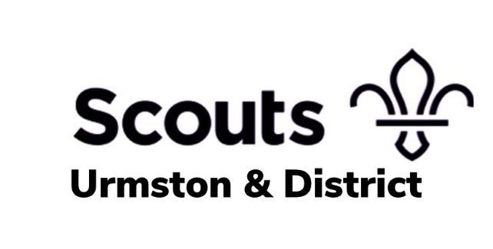
Introduction
Urmston and District Scouts own a 19 plate Peugeot Boxer Minibus Lite. This has 17 seats including the driver and is wheelchair accessible (requiring removal of 4 seats)

- The minibus can be driven under the Section 19 Small Bus Permit Scheme. Permits are available from: Section 19 Minibus permits | Scouts.
- Drivers must be aged 25 and over and below 70.
- Drivers must also have held their licence for at least two years and have had no accidents in the last 5 years (including fault and non-fault), have no motoring convictions or penalty endorsements on their license and no DVLA reportable medical conditions This is a condition of our insurance.
- The wheelchair ramp and clamps must remain in the vehicle at all times when vehicle is in use, even if a wheelchair is not being accommodated. This is a requirement of the Section 19 Permit.

Security Deposit
- A security deposit of £250 must be paid by Bank Transfer prior to collection of Minibus:
Account Name - Urmston and District Scout Council
Bank – TSB
Account Number – 00000605
Sort Code – 77-19-56
Reference – “(Your Group Name) Bus”
- The deposit will be refunded once the Minibus has been checked for condition and any excess mileage.
- Any extra cost or donations, as laid out in our Terms and Conditions, will be deducted from the Security Deposit

Donation Rates
The donations for the use of the minibus are set out in the table below. Please note the minibus will be provided with a full tank of fuel (Diesel) and you must return the bus with a full tank of fuel.

 | Evening | Day (24 hours) | Weekend | Week
17-Seater | £45 | £80 | £150 | £400
Mileage Limit | 100 miles | 200 miles | 400 miles | 1000 miles

- Any miles driven over your mileage limit will be charged at an extra 50p per mile
- You may be subject to extra charges on the return based on fuel level and/or condition of the vehicle. Please see the Terms and conditions for further information

